Monday:
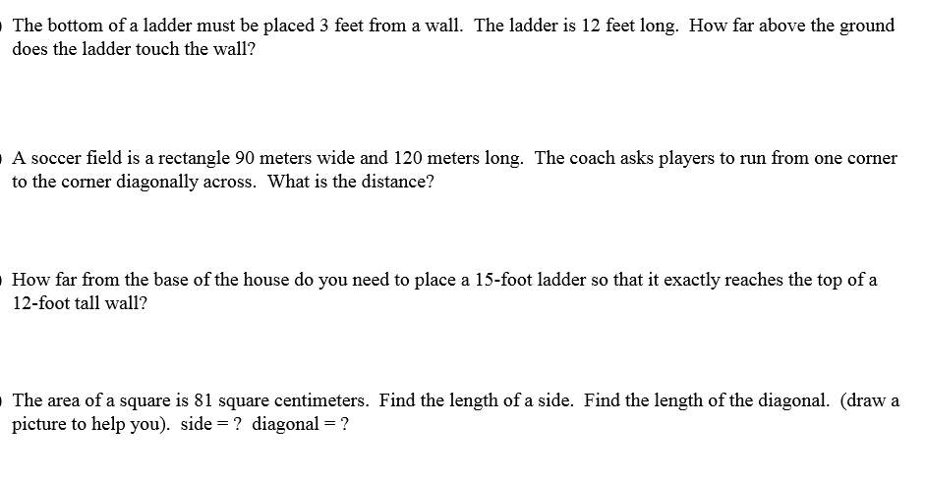
Tuesday: Determine whether each function is linear or non-linear. Explain WHY.

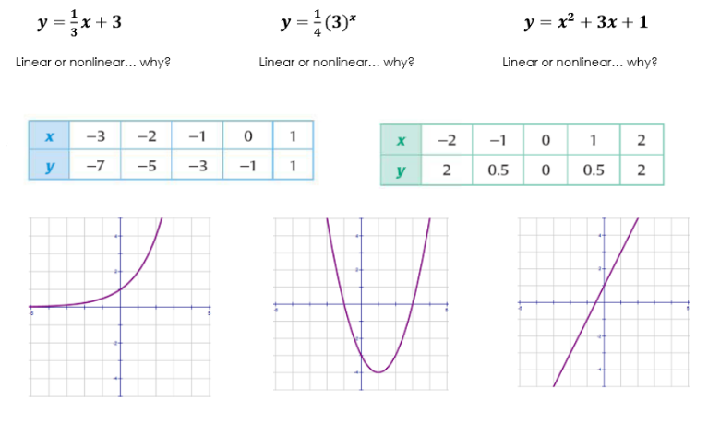
Wednesday:
Write in standard form

3.4 x 10⁵ 2.46 x 10⁻⁴ 1.8 x 10⁷

Write in scientific notation

23,000,000 two hundred thirty-four million .000000765

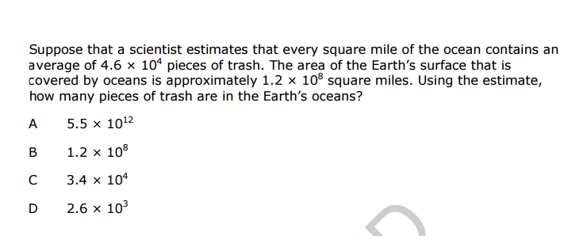
Thursday: Convert all numbers to fractions. Then multiply to solve.
x 0.888... 0. 0909... x
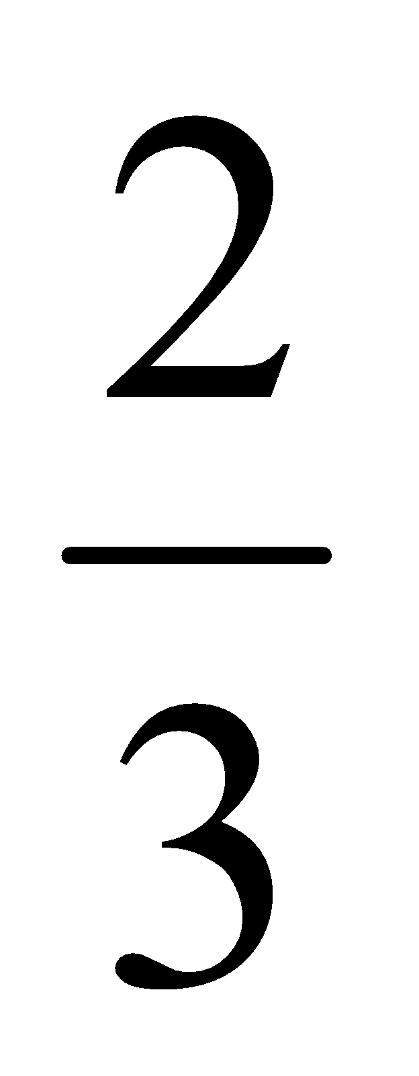x x 0.333...
