Name ________________________________________________ Block _________ HomeFUN Qrt. 3 Jan. 23 - 27, 2017
Monday 1.23.17 (8.F.2): Compare the following functions to determine which has the greater rate of change:

1. Function 1 Function 2 y = 2x + 7
x | -2 | 0 | 2
y | -3 | 3 | 9

2. Function 1: Mike currently has $25. His mother gives him $5 more per week.

Function 2: Ronny has $20 at the start of his day. He spends $2 on each snack that he buys.

3. Compare the following functions to determine which has a negative slope:

Function 1: y = 15 – 5x

Function 2: y = 15 + 5x

Tuesday 1.24.17 (8.F.3): Determine if each function is linear or nonlinear. Explain your reasoning.

x | y
1 | 8
3 | 9
5 | 11
7 | 14

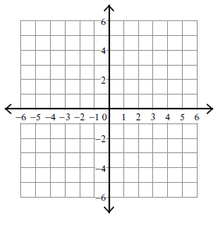

y = 2x + 5
Wednesday 1.25.17 (8.F.2): Read each question. Answer the questions that follow. 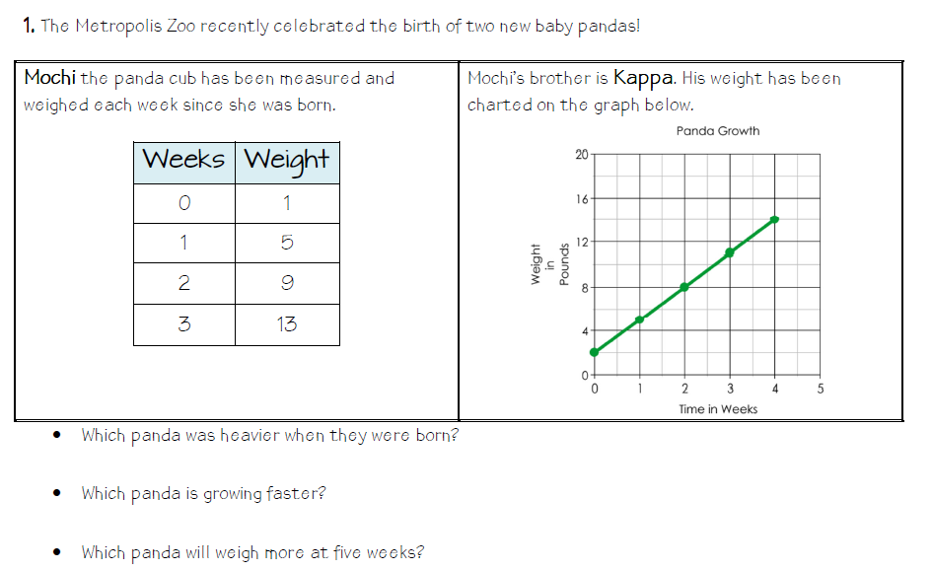
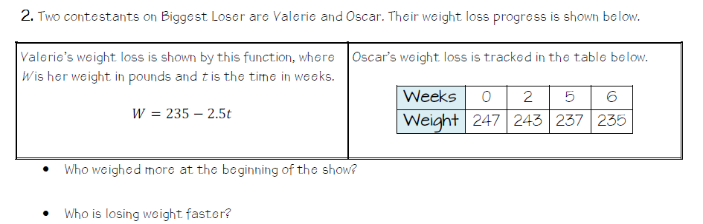
Thursday 1.26.17 (8.F.2): Read each question. Answer the questions that follow.
