Name ________________________________________________ Block _________ HomeFUN Qrt. 3 Jan. 30 – Feb. 3, 2017
Monday 1.30.17: Answer each question, show ALL work for full credit.
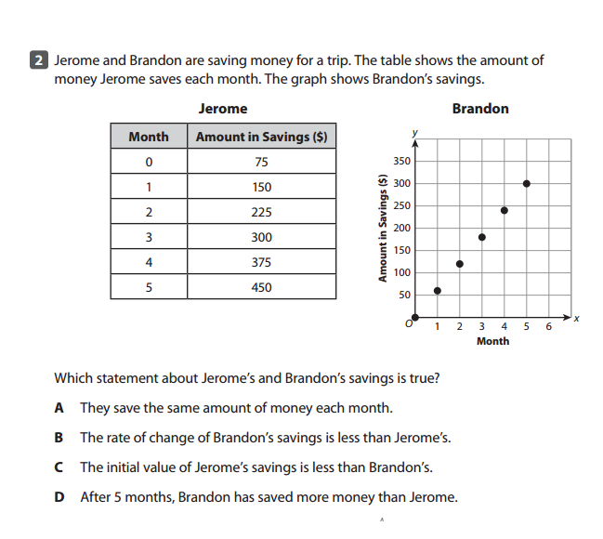
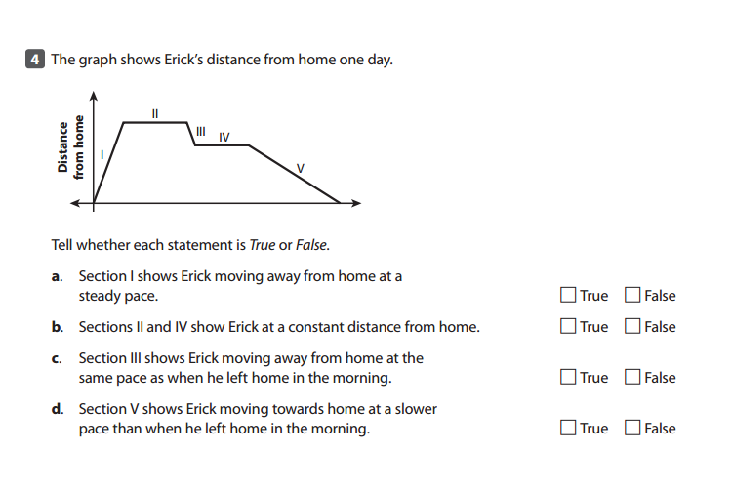
Tuesday 1.31.17: Answer each question, show ALL work for full credit.
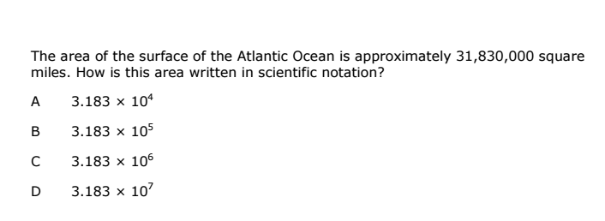
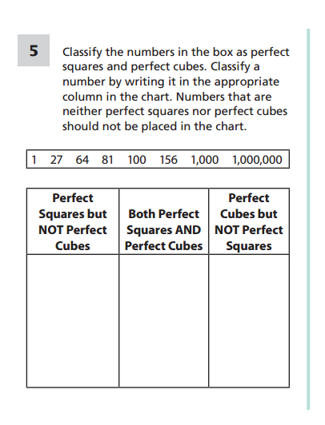

Wednesday 2.1.17: Answer each question, show ALL work for full credit.
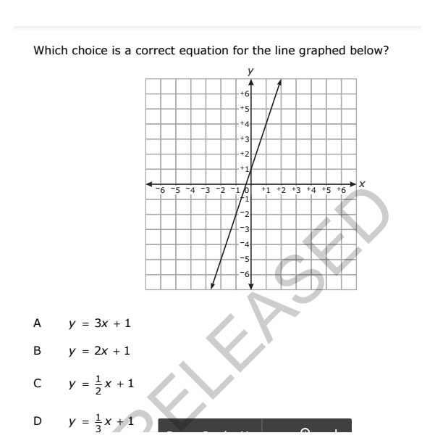
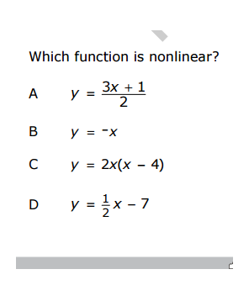

Thursday 2.2.17:
