Name ________________________________________________ Block _________ HomeFUN Qrt. 3 Feb. 6 – Feb. 10, 2017
Monday 2.6.17: Answer each question below. Show ALL work for full credit.
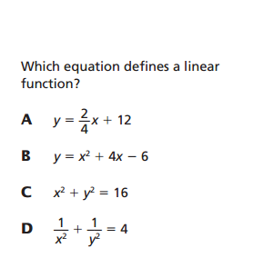
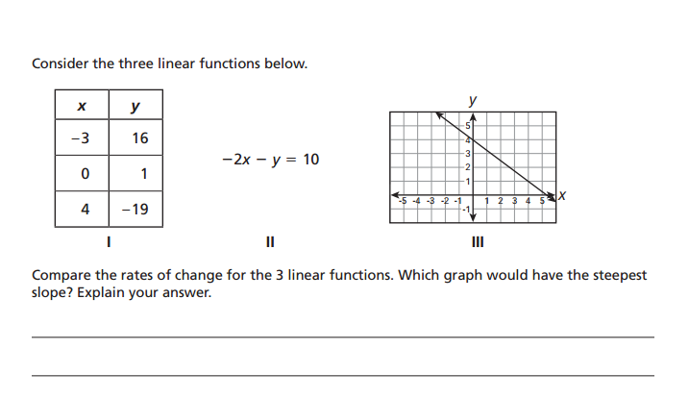

Tuesday 2.7.17: Answer each question below. Show ALL work for full credit.
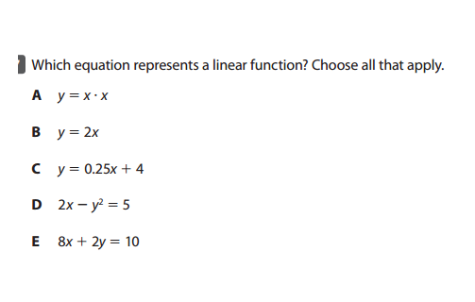
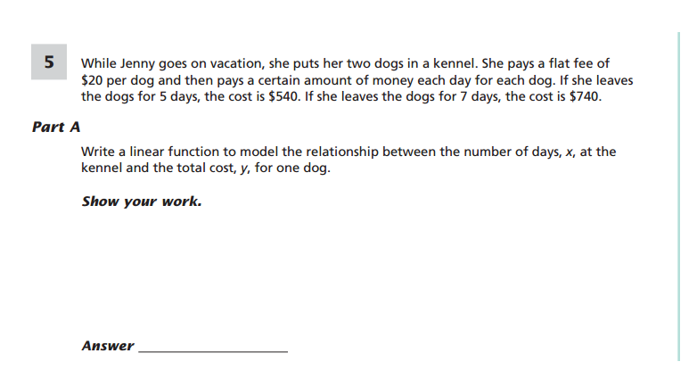

Wednesday 2.8.17: Answer each question below. Show ALL work for full credit.
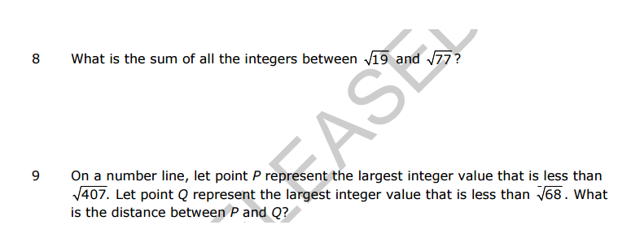

Thursday 2.9.17: Answer each question below. Show ALL work for full credit.
