Name ________________________________________________ Block _________ HomeFUN Qrt. 3 Feb. 21 – Feb. 24, 2017
Tuesday 2.21.17: Use the graph to find the slope, y-intercept, & write the equation of the line.
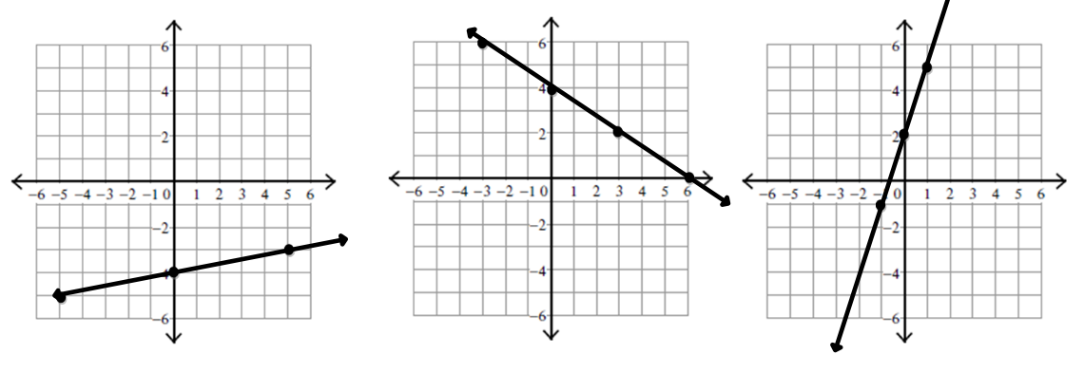
Slope (m) _____________ Slope (m) _____________ Slope (m) _____________
Y-intercept(b)__________ Y-intercept(b)__________ Y-intercept(b)__________
Equation(y = mx + b) ___________ Equation(y = mx + b) ___________ Equation(y = mx + b) __________

Wednesday 2.22.17: Read each question & answer it with detail. Show ALL work!
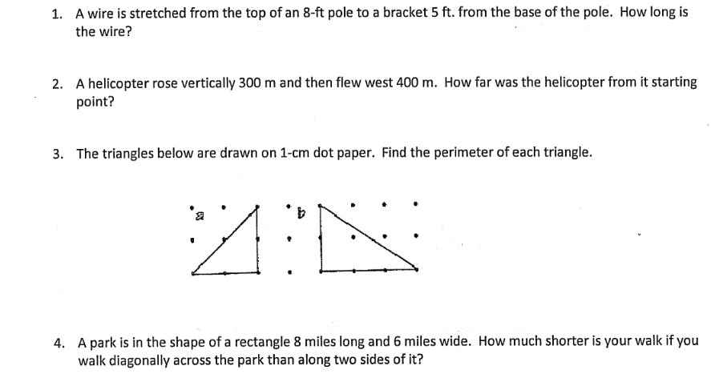

Thursday 2.23.17: Read each question & answer it with detail. Show ALL work!

Roberto owns a carpet cleaning service. He charges a $100 service charge plus $35 per room. Write an equation in slope intercept form that represents the relationship between the total cost of a cleaning job, y, and the number of rooms Roberto cleans, x.

John entered a hot dog eating contest. If he wins, he will receive a grand prize of $500 plus $20 for every hot dog he eats. If John uses the equation y = 20h + 500, how many hot dogs did John eat if he won a total of $1100?

You are visiting Washington, DC and a taxi company charges a flat fee of $3.00 for using the taxi and $0.75 per mile.

- Write an equation in slope intercept form that you can use to find the cost of a taxi ride in Washington, DC.
- How much would a taxi ride cost for 8 miles?
- If a taxi ride cost $15, how many miles did the taxi travel?

- B. C.

